[Add questions]

Technical Document

Date: 20/Feb/2019

Version: Version 0.1

# Table of Contents

Table of Contents 1

[Task Name] 2

Description 2

1.1 Mockup screen: 2

1.2 Angular & Spring Models 3

1.3 Angular Component 4

1.4 Rest Services 4

1.5 Flow Services: 4

1.6 Repository Functions 5

1.7 Database Script: 5

1.8 ER Diagram: 7

# 

# [Task Name]

Refer to: [Taiga URL]

## Description

add questions to quiz.

## Mockup screen:

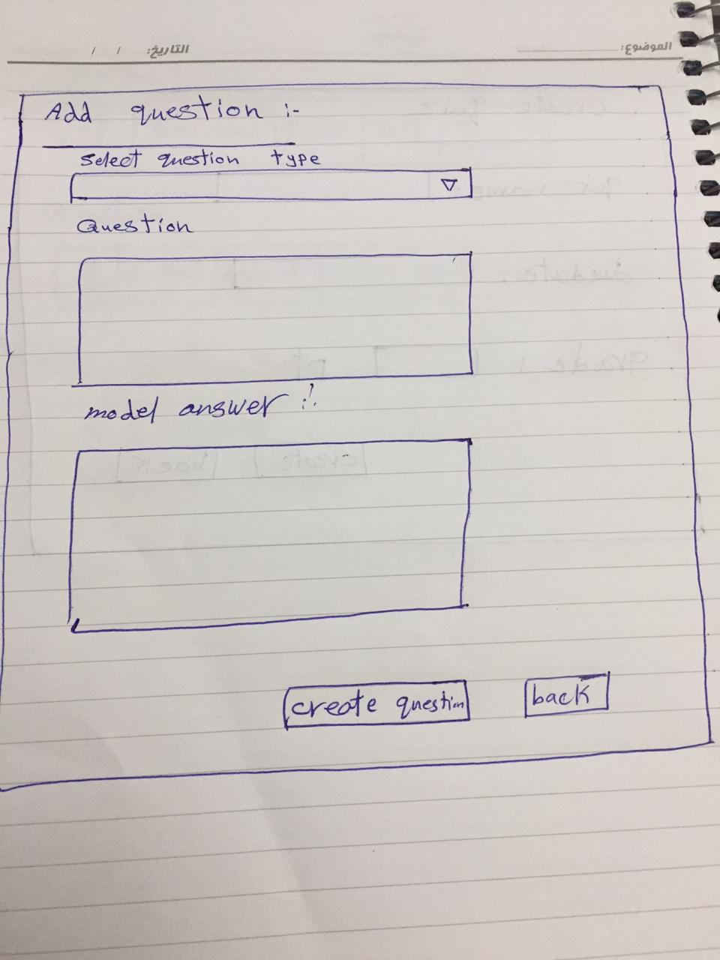

## Angular & Spring Models

|  |  |  |  |
| --- | --- | --- | --- |
| **New** | **Class Name** | QuestionDTO | |
| **Angular Path** | | app/modules/course/shared/data/quiz/question-dto.ts | |
| **Spring Path** | | model/course/QuestionDTO | |
| **Fields** | | | |
| **Attribute** | | **Data Type** | **Spring Data Type** |
| id | | number | int |
| quizID | | number | int |
| questionTypeID | | number | int |
| question | | string | String |
| modelAnswer | | string | String |
| answer1 | | string | String |
| answer2 | | string | String |
| answer3 | | string | String |
| answer4 | | string | String |

|  |  |  |  |
| --- | --- | --- | --- |
| **New** | **Class Name** | QuestionType | |
| **Angular Path** | | app/modules/course/shared/data/quiz/question-type.ts | |
| **Spring Path** | | model/lookup/QueestionType | |
| **Fields** | | | |
| **Attribute** | | **Angular Data Type** | **Spring Data Type** |
| id | | number | int |
| labelEN | | string | String |

## Angular Component

|  |  |  |
| --- | --- | --- |
| **New** | **Class Name** | AddQuizQuestions |
| **Path** | | app/modules/course/components/quiz/add-quiz-questions.[ts/html] |
|  | |  |
| **new** | **Class Name** | QuizService |
| **Path** | | app/modules/course/shared/quiz.service.ts |
| **Function** | | addQuizQuestion(question: QuestionDTO) |

|  |  |  |
| --- | --- | --- |
| **new** | **Class Name** | LookupService |
| **Path** | | app/layout/shared/lookup.service |
| **Function** | | getAllQuestionsTypes() ; |

## Rest Services

|  |  |  |  |  |  |  |  |
| --- | --- | --- | --- | --- | --- | --- | --- |
| **New** | **Name** | | /api/lookup/questionTypes | | | **Method** | GET |
| **Controller** | | | LookupRes | | | **Function** | getAllQuestionTypes() |
| **REST Parameter** | | | | | | | |
| **Attribute** | | **Parameter Type** | | **Data Type** | **Description** | | |
| N/A | | N/A | | N/A |  | | |

|  |  |  |  |  |  |  |  |
| --- | --- | --- | --- | --- | --- | --- | --- |
| **New** | **Name** | | /api/quiz/{quizID}/question/ | | **Method** | | POST |
| **Controller** | | | QuizRes | | **Function** | | createQuizQuestions (int quizID, List<QuestionDTO> questions) |
| **REST Parameter** | | | | | | | |
| **Attribute** | | **Parameter Type** | | **Data Type** | | **Description** | |
| questions | | Payload | | List<QuestionDTO> | |  | |

## Flow Services:

|  |  |  |  |  |
| --- | --- | --- | --- | --- |
| **New** | **Class Name** | QuizSer | **Function** | createQuestions(QuestionDTO[]) |
| **Description** | | Add quiz questions | | |
| **Steps** | | | | |
| 1-Insert question Data in Database | | | | |

|  |  |  |  |  |
| --- | --- | --- | --- | --- |
| **New** | **Class Name** | LookupSer | **Function** | getallQuestionsType() |
| **Description** | | Get available Types of the questions | | |
| **Steps** | | | | |
| 1. Select types of questions from database. | | | | |

## Repository Functions

|  |  |  |  |  |
| --- | --- | --- | --- | --- |
| **New** | **Class Name** | QuizRep | **Type** | Insert SQL |
| **Function** | | insertNewQuestion(QuestionDTO question) | | |
| **Query** | | | | |
| INSERT INTO question (question, model answer ) VALUES (?, ?) | | | | |

|  |  |  |  |  |
| --- | --- | --- | --- | --- |
| **New** | **Name** | lookupR | **Type** | Select SQL |
| **Function** | | getAllQuestionsTypes() | | |
| **Query** | | | | |
| SELECT * from question_type ; | | | | |

## Database Script

**CREATE TABLE** question (  
**id INT NOT NULL** AUTO_INCREMENT,  
**question_content VARCHAR**(500) **NOT NULL**,  
**question_answer VARCHAR**(500) **NOT NULL**,  
**answer1 VARCHAR**(500) **NULL**,  
**answer2 VARCHAR**(500) **NULL**,  
**answer3 VARCHAR**(500) **NULL**,  
**answer4 VARCHAR**(500) **NULL**,  
**quiz_id INT NOT NULL**,  
**quiz_question_type_id INT NOT NULL**,  
**PRIMARY KEY** (**id**),  
**CONSTRAINT** fk_question_quiz  
 **FOREIGN KEY** (**quiz_id**)  
 **REFERENCES** quiz (**id**)  
 **ON DELETE NO ACTION  
 ON UPDATE NO ACTION**);

**ALTER TABLE** question  
**ADD CONSTRAINT** fk_question_quiz_question_type  
 **FOREIGN KEY** (**quiz_question_type_id**)  
 **REFERENCES** question_type (**id**)  
 **ON DELETE NO ACTION  
 ON UPDATE NO ACTION**;

**CREATE TABLE** question_type (  
**id INT NOT NULL** AUTO_INCREMENT,  
**label_en VARCHAR**(45) **NOT NULL**,  
**PRIMARY KEY** (**id**));

## ER Diagram:

